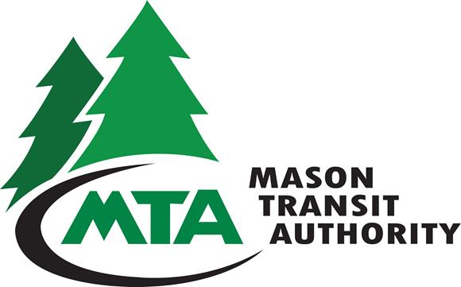
VANPOOL RIDER AGREEMENT

I will pay my monthly vanpool rider fee as established by Mason Transit Authority (MTA), promptly to MTA by the 9th of each month for which it is being paid. I understand if my payment is not paid on or before the 9th, there will be a fee of $10.00 assessed. I also understand that if I do not pay my bill that I could be subject to removal from my vanpool and/or my bill may be sent to a collection agency. I also understand that all fares are non-refundable and adjustments to bills will not be made after they have been sent out. If I leave the vanpool with a credit, I understand that I forfeit that credit.

I will Release and Hold Harmless MTA, it’s authorized agents and the Driver from liability claims and demands for personal injury (such as termination from employment), for loss, theft or damage to personal property; for claims, actions, costs, damages, or expenses of any nature whatsoever arising out of or resulting from any delays, tardiness, failure to make an appropriate or scheduled pick-up, absence of the van on particular days; and for termination of the program. This is not meant to include claims for liability or personal injury resulting from accidents, which are covered under Mason Transit’s Auto Liability and Accident Insurance.

I will abide by all rules which may from time to time be promulgated by MTA.

I will abide by all day-to-day operational rules (i.e., pick-up/drop-off times and places, length of waiting time, choice of radio stations/music, etc.) as established by the majority vote of the vanpool members or by MTA as a result of arbitration of disputes arising out of the day-to-day operational vanpool rules.

I will comply with reasonable requests from the Driver, speak and behave in a reasonable and courteous manner, cooperate with other riders, and demonstrate good personal hygiene as a courtesy to the entire vanpool (includes using colognes/perfumes in reasonable amounts, etc.).

I will give at least one day advance notice to the Driver of the days/times I know I will be absent from the vanpool. On these days of absence, I will find my own alternate transportation. I will also contact the driver when an unexpected illness or condition arises which will keep me from riding on a given day. I understand there will be no monthly fare deduction for occasional absence from the vanpool.

I will find alternate transportation on days when the van may not be available.

I will submit written notification to the primary driver and submit a Vanpool Participant Withdrawal Form to MTA by the 9th of the month prior to my planned withdrawal from the vanpool. I understand that if proper notification of withdrawal from the vanpool has not been turned in by the 9th of the month prior to my planned withdrawal the monthly fare is still due.

I understand that use of any tobacco product which includes but is not limited to e-cigarettes or vapor cigarettes, illegal drug use or possession which includes but is not limited to marijuana and drinking or transporting alcohol in the van is not allowed.

I will notify MTA immediately if a Driver is operating the van in a non-defensive or unsafe manner.

I will not drive the van without MTA’s approval.

I will assist in maintaining and/or increasing the vanpool ridership to its maximum level.

I will cooperate to ensure that no person shall be denied the opportunity to participate in, nor be subjected to discrimination in the conduct of the vanpool program because of race, creed, color, sex, age, national origin, nor the presence of any sensory, mental, or physical handicap, nor in any manner contrary to applicable local ordinance, state or federal laws and regulations, specifically including Title VI of the Civil Rights Act of 1964, Title 49, Code of Federal Regulations, Part 21, Non-Transportation, and Chapter 46.60, Revised Code of Washington Law Against Discrimination.

This Agreement shall be effective as of the date of its signing and shall continue until terminated (for any reason) by either MTA or myself. This Agreement may be modified only by subsequent written agreement signed by each of the parties.

_____
Rider Name (Please Print) Home Phone Work Phone

_____________________________________________________________________________
Physical Address:

_____________________________________________________________________________
Mailing Address

Employer Employer Address/Bldg #

____________________________________ __ ______________
Email Address Vanpool Group # Start Date

As a vanpool rider, I have read this Vanpool Rider Agreement and agree to abide by the conditions listed.

Rider’s signature: Date ____________

Please sign completed agreement and return to
Mason Transit Authority
790 E Johns Prairie Rd
Shelton, WA 98584

If you have a question, please call Kathy Geist
360 432-5754
1-800-374-3747 ext.154
kgeist@masontransit.org

