w
2019-2024
TRANSIT DEVELOPMENT PLAN
and
2018 Annual Report

Mason Transit Authority
790 E Johns Prairie Rd
Shelton, WA 98584

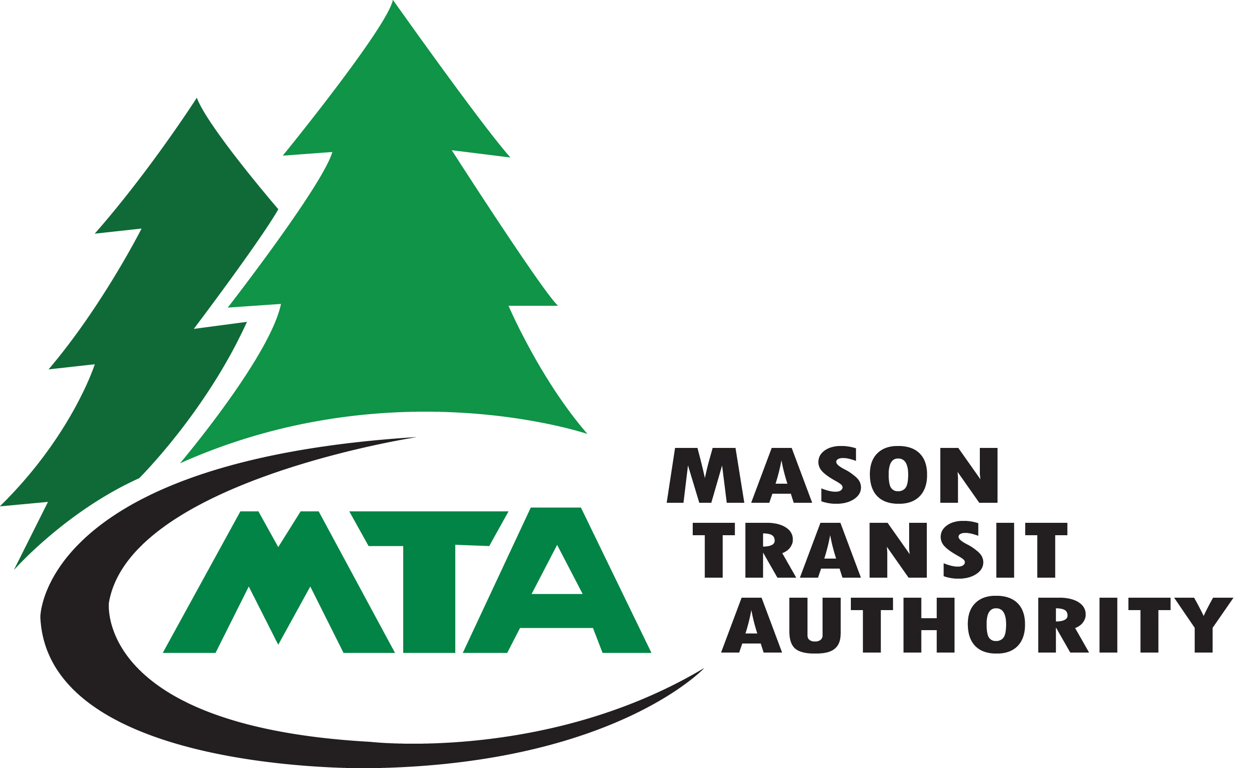

Date of Public Hearings:
July 2, 2019 and July 10, 2019
Adopted on: _________________, 2019

Prepared by Mason Transit Authority Staff
Table of Contents

Section Title Page

I Organization 1

2 Physical Plant 4

3 Service Characteristics 4

4 Service Connections 7

5 Activities and Accomplishments in 2018 8

6 Proposed Action Strategies for 2019 – 2024 13

7 Operating Data, 2018 (Actuals) – 2019-2024 18
(Projected)

8 Operating Revenues, Expenditures, and Capital 19
Budget Plan 2018 (Actuals) -2019-2024
(Projected)

9 Mason Transit Authority Route and Service Area 21
Maps

Title]

Section 1: Organization

Mason County Public Transportation Benefit Area, doing business as Mason Transit Authority (MTA), is a Public Transportation Benefit Area (PTBA), authorized in Chapter 36.57A RCW. Located in Mason County, Washington, the Mason County voters approved the PTBA in November 1991 and began public transportation service in December 1992. The service area includes all of Mason County, if road access is available, with connections to adjacent counties.
The proposition imposing a sales and use tax of two-tenths of one percent (0.2%) to fund public transportation was also passed in 1991, creating a prepaid fare system service. In the aftermath of Initiative 695 and the elimination of Motor Vehicle Excise Tax that was available to transits, the voters were asked to approve an additional four-tenths of one percent increase (0.4%) in 1999. The first attempt failed but was successful when County residents responded with an approval of the additional sales tax increase on September 18, 2001. This raised the taxing base to six-tenths of one percent (0.6%) or $.06 on every $10 of retail sales, effective January 1, 2002. MTA then began to charge a fare, but only for routes going out-of-county.
Board of Directors:
The Mason County Public Transportation Benefit Authority Board of Directors is composed of ten members as follows:
- Three (3) elected members representing Mason County Commissioners;
- One (1) elected member representing the City of Shelton Council;
- Five (5) members who shall be elected officials selected by the Mason County Commissioners with the goal of seeking equal voting representation among the County Commissioner Districts. The recommendation was approved by Mason County and the City of Shelton pursuant to Resolutions Nos. 71-17 and 1112-1217, respectively; and
- In accordance with revisions made to RCW 36.57A.050, there shall be one (1) non-voting labor representative recommended by the labor organization representing the public transportation employees.
Mason County Public Transportation Benefit Authority (MTA) Board Members at time of publication are:
- Randy Neatherlin, Mason County Commissioner (Chair)
- Wes Martin, Grapeview School District (Vice Chair)
- Sharon Trask, Mason County Commissioner
- Kevin Dorcy, City of Shelton Council Member
- Kevin Shutty, Mason County Commissioner
- John Campbell, North Mason School District
- Deborah Petersen, Hood Canal School District
- Sandy Tarzwell, Shelton School District
- Don Pogreba, Southside School District
- Greg Heidel, Bargaining Unit Representative

Citizen Adviser to the Board:
Effective January 1, 2019, there may be one (1) non-voting representative of the public residing in Mason County, Washington, as a citizen adviser to the Board. The citizen adviser to the Board shall serve for a period of one year (unless extended by motion by the Authority Board).
At the time of publication of the Transit Development Plan, the position of the Citizen Adviser to the Board was filled by:
- John Piety
Employees:
MTA employs 70 full-time employees, 1 seasonal driver and 8 Worker/Drivers. The International Association of Machinist and Aerospace Workers (IAMAW) Lodge #160 represents 54 employees as denoted in the below table with an asterisk (*). The following charts detail employee count by department and MTA’s organizational structure.

Department | Employee Count | Full-Time Equivalent (based on 40 hr. week)
General Manager | 1 | 1.00
Administrative Services | 5 | 5.00
Maintenance – Administration | 2 | 1.50
Maintenance – Facilities * | 2 | 2.00
Maintenance – Vehicle * | 6 | 6.00
Operations – Administration | 6 | 6.00
Operations – Scheduling/Dispatch * | 7 | 7.00
Operations – Operators * | 39 | 38.42
Operations – Worker/Drivers | 8 | 2.5
T-CC – Administration and Facilities | 2 | 2.00
Total | 78 | 71.42

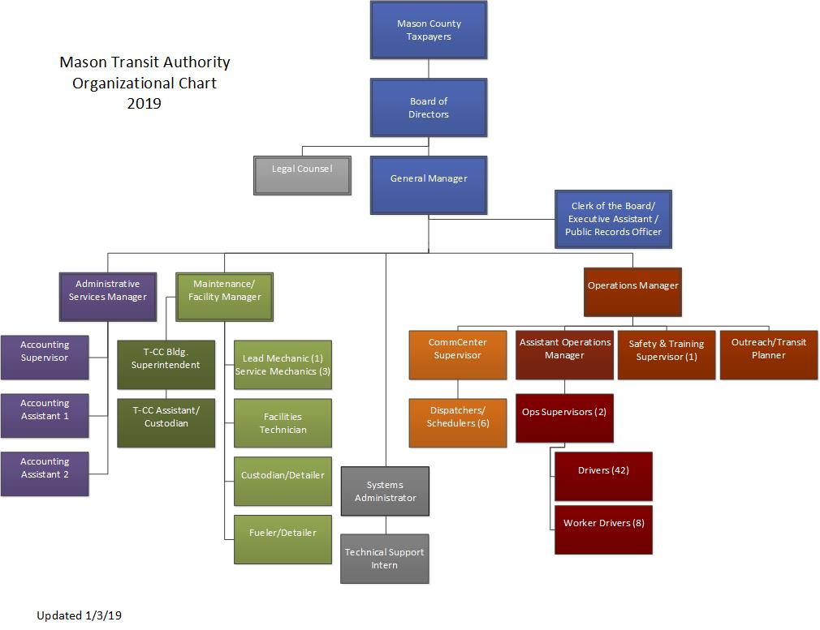

Section 2: Physical Plant

MTA operations, maintenance and administrative facilities are located at 790 E. Johns Prairie Road in Shelton, Washington. A rented satellite operations facility is located at 23780 NE State Hwy 3 in Belfair, Washington. MTA also leases space at the Glacier West Boat, RV & Self Storage commercial storage facility on SR 106 in Belfair to park two coaches and five cutaway vans used to provide services in the northern part of Mason County.
MTA owns the Transit-Community Center, formerly the Shelton Armory, located at 601 W. Franklin St. in Shelton, Washington. The facility was renovated with additional new construction transforming the original armory built in the 1950’s to a modern, ADA accessible and LEED Silver Certified Transit-Community Center (T-CC).
A seven-acre parcel was purchased north of Belfair for a Park and Ride lot. The lot will contain 100 parking stalls and a building consisting of MTA office space, a meeting room, bathrooms, a kitchen and breakroom. The Park and Ride is slated to open in late summer of 2020.

Section 3: Service Characteristics

MTA provides transportation services consisting of local and regional deviated fixed routes, Worker/Driver commuter service to Puget Sound Naval Shipyard (PSNS) and public commuter services on high demand regional routes, Demand Response (general dial-a-ride), Vanpools and volunteers using private cars under the Volunteer Driver Program that serves those over the age of 60 needing out-of-county services.
Hours of operation of the transportation service are 4:00 a.m. to 8:30 p.m., Monday through Friday, and 6:00 a.m. to 8:30 p.m. on Saturday. There is no service on Sunday, and either no service or reduced service on observed holidays. MTA operates ten (10) Fixed Routes on weekdays and nine (9) routes on Saturdays that allow minimal deviated service to persons traveling off designated routes. Dial-A-Ride service operates in rural areas where there is no fixed route service or where deviations are not possible as well as in populated areas of Mason County for people who have difficulty using the routed service. All Dial-A-Ride service is open to the general public. Riders using Dial-A-Ride can make a trip request from two (2) hours before to two (2) weeks prior to the preferred pick-up time. All vehicles in MTA scheduled service are equipped with bike racks and are accessible to persons with disabilities.

Fares:
Travel within Mason County and Active Military Fare Free
Out of County Travel:
Cash Fares
Adults and Youth (one way) ………………………………………………………………….. $1.50
Seniors and Persons with Disabilities ……………………………………………………. $ .50
Transportation Incentive Program (PSNS) ….……………………………………….. $ 2.50
Children six and under ………………………………………………………………………….. No Charge
Monthly Pass
Adults ……………………………………………………………………………………………………. $ 30.00
Seniors and Persons with Disabilities ……………………………………………………. $ 10.00
Youth (ages 7-17 years) ………………………………………………………………………… $ 18.00
Summer Youth Adventure Pass …………………………………………………………….. $ 20.00
Transportation Incentive Program (PSNS)……………………………………………… $110.00

To qualify for reduced fare due to a disability, riders are required to show a Regional Reduced Fare Permit (RRFP) card. RRFP eligibility is based on age, disability or possession of a Medicare card. Personal care attendants ride free when accompanying a person with a RRFP. Transportation Incentive Program (TIP) passes are available for Worker/Driver routes to and from Puget Sound Naval Shipyard for day shift employees. Routes originate in Belfair and Shelton. Active-duty military personnel with current military ID are not charged fare if ID is shown.
In July 2018, MTA began recognizing the STAR pass for State of Washington employees living in Mason County that work in Thurston County. STAR pass holders are not charged a fare and MTA is compensated through the funds provided in the Transportation budget.
Coordinated Service
MTA coordinates all service requests with other local and regional area transportation providers. Squaxin Transit coordinates local service with MTA regional service at Kamaliche. MTA partners with local and regional human and social services providers so that the best service possible is provided throughout the region on a regular basis.

Volunteer Service
MTA administers a Volunteer Driver Program (VDP) that is possible through partnership with the Lewis, Mason and Thurston County Area Agency on Aging and funding from the Federal Older Americans Act and the Washington State Senior Citizens Act, as well as donations from recipients. The VDP provides essential transportation for seniors (60+) who are unable to drive or use public transit to their out-of-county medical appointments and other essential services. To provide this service, MTA utilizes volunteers that donate their time and drive their own vehicles. In 2018, the Volunteer Driver Program served 101 clients and covered 1,543 rides, 71,134 miles and 3,077 volunteer hours.

Vanpools
MTA’s vanpool program started in 2005. At time of publication, MTA has a fleet of 12 vanpool vans to promote statewide ridesharing goals and benefits to commuters living or working in Mason County. This program complements Mason Transit Authority’s network of local and express services, providing commute alternatives to destinations that cannot be effectively served by Fixed Route services. In 2018, Mason Transit Authority Vanpools provided over 19,855 rides, 6% of the agency’s fixed route ridership. 2018 ended with 8 active vanpools.

Park and Ride Lots
MTA supports a network of Park and Ride facilities that are located throughout Mason County. At time of publication, 255 parking spaces are provided at facilities owned and operated by Washington State Department of Transportation, Mason County and the City of Shelton. While MTA manages and provides routine light maintenance to these locations, the agency does not own the properties. On average, 37 percent of the Park and Ride lot capacity is occupied on any given weekday.
In November of 2015, MTA was formally awarded funding through the Washington State Regional Mobility Grant Program and the Connecting Washington Transit Project List for a major retro-fit and improvement project of current Park and Ride lots located within Mason County. The project will add needed upgrades to existing locations including enhanced security, lighting, paving and electric car charging stations at high use lots. The project also includes the building of one new Park and Ride facility in North Mason County and one within the city limits of Shelton. The Shelton-Matlock Park & Ride was slated for improvements only but will now be relocated due to the Coffee Creek Fish Passage project. The funding provides over nine million dollars and includes local matching funds from MTA. The state funding is apportioned over the current and next biennium budget periods. In April of 2016, MTA selected SCJ Alliance of Lacey, Washington, to guide the project through to completion. MTA expects completion of the project in early 2023.

Section 4: Service Connections

Regional connections with other transit systems occur Monday through Saturday with Intercity Transit, Sound Transit and Grays Harbor Transit in Olympia; Kitsap Transit and the Washington State Ferry system in Bremerton; and Jefferson Transit at Triton Cove State Park. Regional connection with Squaxin Transit occurs Monday through Friday at the Squaxin Island Tribe Park and Ride Facility near the intersection of SR-101 and SR-108.
The majority of MTA’s connecting services are at transfer facilities located near services that allow connections to other ground transportation including Washington State Ferries in Bremerton and Greyhound and Amtrak in Olympia.
Service is available to persons traveling to and from area schools including Olympic College, South Puget Sound Community College, Evergreen State College, and Grays Harbor College by using MTA to transfer to Intercity, Grays Harbor and Kitsap Transit systems at respective transit centers.
Route schedules can be found on MTA’s website at http://www.masontransit.org/

Section 5: Activities and Accomplishments in 2018

Activities
MTA staff is committed to public engagement and transparency through robust public interaction that informs, involves, and empowers people and communities. Staff participated in several opportunities to promote and educate citizens through the following methods:
    - Public meetings
    - Media – outreach
    - Radio spots
    - Community events and meetings
    - Presentations
    - Website improvements

In 2018, major events included Forest Festival, Allyn Days, Taste of Hood Canal, Business Expos, Career Days, Oysterfest and the Christmas Parade. MTA sponsored events for the Economic Development Council and the Shelton-Mason County Chamber of Commerce. The Outreach/Transit Planner promotes MTA services throughout the community as well as service planning to better meet the needs of riders.

MTA continued efforts in strategic planning and implementation of goals, objectives and work plans. Annually, we review the work plan to create projects to meet the goals of constant adherence to guidance provided through local, state and federal oversight implementing all service planning and effective/efficient changes, fleet replacement standards, facility upgrade and modernization planning and implementation, policy development and modification, and procedural standards.
MTA incorporates the Transportation System Policy Goals throughout all strategies. These goals as addressed in RCW 14.04.280 include preservation, safety, mobility, environment, and stewardship.
In 2018, Mason Transit Authority accomplished the following, aligning with each goal:

Preservation: “To maintain, preserve and extend the life and utility of prior investments in transportation systems and services.”

- No substantial service changes to system
- MTA preserved current service levels.
- Received five Champion cutaway buses
- The replacement of five cutaways was secured through a grant from the Washington State Department of Transportation. This replaced cutaways beyond usual life.
- Received four mini-vans
- The purchase of four mini-vans through Vanpool Investment Program replaced vans that were beyond useful life.
- Transit Asset Management (TAM) Plan
  - Prepared TAM as required by the Washington State Department of Transportation and the Federal Transit Administration.
- Transit-Community Center (T-CC) Parking Lot
  - Continued work on the design of the T-CC parking lot with partnership with the city of Shelton and the Mason County Conservation District. Project is funded by the Department of Ecology and local funds.

Safety: “To provide for and improve the safety and security of transportation customers and the transportation system.”

- Rear Destination Signs
- Installed rear destination signs on coaches for passenger safety and security improvement.
- Training
- MTA continues to have a rigorous training program for new drivers. Refresher training and retraining of all drivers occurred throughout 2018 to ensure and improve safety.
- Volunteer Safety Audit
- Through the Washington State Department of Labor and Industries, MTA schedules a Volunteer Safety Audit annually. MTA facilities, systems and safety management methods are reviewed by an L&I inspector. The inspector gives recommendations that are either incorporated into daily practices, or immediately corrected. This process has proven invaluable to the agency in the prevention of work-related accidents.
- Best Practices
- MTA continued to implement Best Practices and improve policies and procedures related to safety of staff, customers and the public as part of an annual review by the Washington State Transit Insurance Pool.
- Safety Committee
- The Safety Committee continued to provide insight and recommendation for the agency on a regular basis by reviewing safety policies and procedures as well as seeking opportunities to improve safety through increased awareness. The Committee recently reviewed and updated the Health and Safety Manual.
- AVL
- Automatic Vehicle Location is in the process of being installed. This will allow Operations to know where service vehicles are at a given time.

Mobility: “To improve the predictable movement of goods and people throughout Washington State”
- CAD/AVL
- Computer Aided Dispatch (CAD) and Automatic Vehicle Location (AVL) software and equipment is in the process of being installed on coaches and cutaway buses. The ability to track movement of buses will help with predictability for riders and dispatch as well as provide safety awareness.
- Comprehensive Service Review
  - To improve the mobility of Mason County residents, a Comprehensive Service Review was conducted in 2018 with the help of an outside consultant. The review includes an Existing Conditions Report, public outreach to riders and non-riders, stakeholder interviews and recommendations for service improvements.
- Continued to review current connections, route times and coordination with regional agencies, including Kitsap, Jefferson and Intercity Transit systems.
- Incorporated Token Transit mobile app for purchasing passes (completed early 2019).

Environment: “To enhance Washington’s quality of life through transportation investments that promote energy conservation, enhance healthy communities and protect the environment”
- Greenhouse Gas Reduction
- MTA created an intensive Greenhouse Gas Reduction Policy early in 2014 in concurrence with the State and Federal requirements and the Washington State Clean Air Act. The policy provides guidance in all areas including vehicle procurement, use of carbon-based fuels, recycling and construction projects undertaken by the agency. See http://apps.leg.wa.gov/rcw/default.aspx?cite=70.94 for more information.
- Park & Ride Lots
- The design and architecture of the new North Mason Park & Ride, the T-CC Parking Lot and upgrades to existing lots will include green technologies such as impervious paving, low emission systems, energy efficiency, and other environmental, security, lighting and landscape enhancements.
- Alternative Fuel
- Bio Diesel (B5) is used for those vehicles using diesel fuel including both small and large revenue vehicles.
- MTA applied for and was awarded a grant for two hybrid buses. An additional grant was submitted in May 2019 for two more hybrid buses. We are awaiting results of the second grant at the time of publication.
Stewardship: “To continuously improve the quality, effectiveness and efficiency of the transportation system”
- Staff
- MTA maintained its comprehensive Driver Recruitment and Training Program. In this highly competitive process, all new drivers must meet the highest standards of the organization and the training they receive is of the highest quality. To this end, MTA continues to have a high safety record and receive compliments and positive feedback from the users of the service.
- Providing effective communication to staff through a variety of tools such as Report of Performance Counseling, regular evaluations, memos and face-to-face communication was a top priority to ensure employees knew expectations, especially in safety and customer service.
- Long-range Planning and Projecting
- MTA continued efforts in strategic planning and implementation of goals, objectives and work plans. Staff completed performance measurement standards in finance and maintenance with operations still determining measurements as part of the Comprehensive Service Review process. The process will continue with constant adherence to guidance provided through local, state and federal oversight implementing all service planning and effective/efficient changes, fleet replacement standards, facility upgrade and modernization planning and implementation, policy development and modification, and procedural standards.
- Partnerships
- MTA continued to participate in transportation planning with local, regional, state and federal transportation planning organizations by maintaining technical and executive appointments. Staff in these various positions provide Transit Oriented Development (TOD) input, long- and short-range planning assistance, assistance with inside and outside comprehensive plan updates and the input regarding the needs of the ridership.
- In the process, MTA benefits greatly by maintaining partnership, communications and coordination efforts on all fronts, providing an extremely high level of stewardship. Partnerships with local agencies in Mason County promote beneficial stewardship of resources to serve the citizens and enhance the quality of life in Mason County.

Section 6: Proposed Action Strategies for 2019-2024

Through its mission, Mason Transit Authority strives to provide transportation choices that connect people, jobs and community; increasing the quality of life in Mason County. To that end, MTA’s proposed project and action strategies line up with the mission statement and the state’s public transportation objectives.

Implementation of projects and strategies may depend on available funding. Any of the following capital projects to be procured with federal funding assistance are included in the Washington Statewide Transportation Improvement Plan (STIP).

Below describes projects and action strategies planned for 2019 and beyond.

Preservation: “To maintain, preserve and extend the life and utility of prior investments in transportation systems and services.”

2019
- Service Review Results and Implementation
- Staff will review results of the Comprehensive Service Review and implement changes for ridership improvement and to enhance ridership growth.
- Vehicle Replacement
- Replace one staff vehicle and two maintenance vehicles.
- Replace four Worker/Driver buses.
- Replace nine cutaways.
- Transit-Community Center (T-CC) Parking Lot
- Construct T-CC parking lot.
- Capital Improvement Projects
  - Roof on Buildings 3 and 4.
  - Johns Prairie bus parking lot reseal and striping.
- Funding Opportunities
- MTA will explore funding opportunities for vehicle replacement to maintain and preserve service with safe, reliable vehicles.
2020
- Allyn, WA - Transit Center Planning
- Replace one 30’ coach (bus)
- Replace six cutaways
- Purchase generator to power Johns Prairie base
2021
- Replace four 35’ coaches (buses)
- Purchase generator to power T-CC
2022
- Hoodsport, WA – Transit Center Planning
- Replace four agency Van Pool vehicles
- Preliminary design and feasibility for constructing a bus wash/wet maintenance facility at MTA Operations.
- Roof modifications to the maintenance shop to allow for additional headspace for working on hybrid and/or electric buses.
- Look at electric bus infrastructure and overall electric bus performance.
2023
- ADA Retrofit and Remodel of MTA Operations Base Building or replacement of facility.
- Septic upgrade at Johns Prairie
- Completion of Park and Ride Development project.
2024
- Replace two 35’ coaches (buses)
- Construct a satellite shop at the Belfair facility for maintenance.
- Update bus stops and incorporate needed improvements

Strategies
Continue 100 percent adherence to scheduled maintenance requirements for vehicles and facilities per established Asset Management Plan (AMP).

Ensure strategic plans enhance service to the community.

Safety: “To provide for and improve the safety and security of transportation customers and the transportation system.”

2019-2024
- Determine current need for safety equipment and apply for Risk Management Grant from WSTIP.
- Operations Policies
- Develop policies for better safety such as for strollers, carry-on packages and animals (non-service) on board.
- Implement National Incident Management Systems (NIMS) staff training.
- Emergency Preparedness
- Create procedures and training for lockdown and active shooter situation.

Strategies
Retrain all drivers on a regular basis in order to provide consistent, safe service.

Maintain goal through training and education of zero preventable accidents and zero on-the-job injuries.

Install improvements as needed to vehicles that enhance safety such as Passive Restraint for mobility devices.

Improve shelters and bus stops with lighting and other amenities to improve safety and security for transit users.

Mobility: “To improve the predictable movement of goods and people throughout Washington State”

2019-2024
- Construct the Belfair Park and Ride and North Mason County satellite base of operations currently funded by the WSDOT Regional Mobility Program (RMG) and Connecting Washington Transit Project list.
- Install bus stop signs throughout Mason County for designated stops.
- Shift from flag-stop to fixed-stop service in Shelton city limits.
- Enhance all Park and Ride locations within Mason County funded through RMG and Connecting Washington.
- Construct roundabout at Log Yard Road in north Mason County near the new park and ride.

Strategies
Include state of the art systems and ADA improvements in all construction projects, facility improvements and rolling stock procurement undertaken by the agency.

Provide reliable, on-time service to users.

Continue to meet the requirements of the adopted Title VI Plan as required.

Implement service recommendations from the Comprehensive Service Analysis.

Explore partnerships that provide greater opportunities for transporting people in Mason County.

Environment: “To enhance Washington’s quality of life through transportation investments that promote energy conservation, enhance healthy communities and protect the environment”

2019-2024
- Seek opportunities to convert some of MTA fleet to alternative fuel such as hybrid or electric.
- Continued Compliance
- Maintain development in strict accordance with adopted policies and procedures and state and federal requirements.
Strategies
Seek opportunities through a NoLo grant to replace one to three diesel vehicles with electric vehicles.

Assess impact to environment and energy conservation on MTA projects so that the project will enhance the quality of life in Mason County and Washington State to the most feasibility possible.
Stewardship: “To continuously improve the quality, effectiveness and efficiency of the transportation system”

2019-2024
- Continue to incorporate performance measures for improving effectiveness and efficiency.
- Invest in technical training for staff specific to route planning.
- Create a Financial Management Manual to ensure policies are in place for ensuring long-term stability of the transit system.
- Create needed policies for efficiency and effectiveness of the transit system.
- Create new drivers’ lounge and work area at Johns Prairie.
- Expand Operations Team with one Operations Supervisor.
- Recruiting and on-boarding tools for better efficiencies.
- IT network improvements and equipment replacement. Hardware replacement of all desktops.
- Build reserves and prepare 5-year sustainability plan.
- Create an Employee Engagement Plan and a communication expectation plan to better engage employees in MTA’s culture.

Strategies
Explore new options in hiring practices, benefits, wages and positions to attract and retain quality employees that desire to serve the public through safety and exceptional customer service.

Improve transit system through collaborative relationships.

Ensure increasing costs in wages, benefits, fuel and other significant costs are accounted for in long-range projections. Control costs to the best of the agency’s ability while being mindful of meeting strategic goals as a top priority.

Continue to increase public relation opportunities and involvement on boards of local and non-profits as appropriate to public transportation and overall benefit to the community.

Have a robust public outreach program that includes:
- Developing an awareness of MTA services with non-riders through presentations, media and community events.
- Engage riders and the general public by soliciting feedback through active seeking of information by face-to-face interaction and surveys.
- Seek opportunities to increase ridership amongst riders of choice.
- Visit businesses to discover way to assist their employees with transportation, either by using vanpool, fixed-route or Dial-a-Ride.
- Promote positive public image in the community and build relationships throughout.
- Conduct Community Conversations throughout the year to give the public opportunity to give input, suggestions and ask questions about MTA.

Section 7: Operating Data; 2018 (actual) – 2019-2024 (projected)

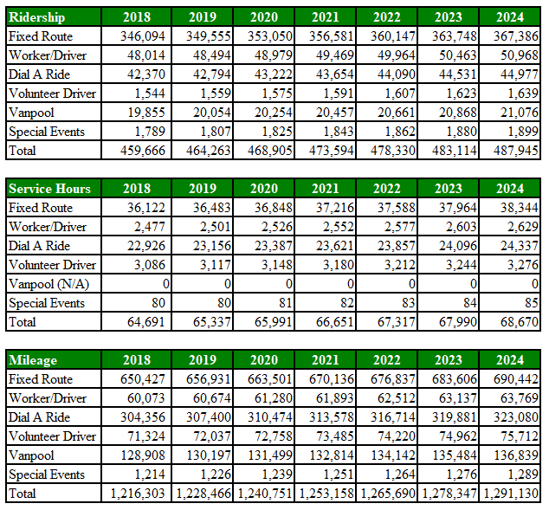

Consumption of fuel for 2018:

Diesel fuel consumed (gal) 143,685
Gasoline consumed (gal) 9,722

Section 8: Operating Revenue, Expenditures and Capital Budget Plan 2018 (actual) – 2019-2024 (projected)

Budget Assumptions through 2024
Operating:
- Local Sales Tax –While the average growth rate of sales tax revenue has been 8% over the past five years, to remain conservative, a 3% growth rate has been used to project out through 2024.
- Investment Interest – Cash balances should remain stable through 2024, a 2% growth rate was assumed through this period to remain conservative.
- Operating Grants – Actual operating grant awards have been used as the projections through 2022, thereafter a 4% growth rate was used.
- Fares – Assumed 2% growth.
- T-CC – Since the T-CC is at max capacity a growth rate of 2% was assumed to keep up with inflation.
- Miscellaneous – Based on 3-year prior average plus 2% growth for inflation.
- Expended Reserves – Based on current projections no expended reserves are deemed necessary.
- Salaries and Benefits – Based on union contracts through 2020 and non-represented compensation assumptions, then assumed 5% growth (3% for benefits and 2% for wages.)
- Fuel – Used 10-year average for fuel in 2020, then assumed 5% growth due to uncertainty in fuel prices since overall operations should not have any major changes.
- Insurance – Used 5-year trend.
- T-CC Expenses – Used T-CC wages based on actual pay, then 2% growth for all other expenses through 2020, 10% thereafter due to potential repairs and maintenance.
- Other Goods and Services – Assumed 4% growth.
- Reserves Allocation – Projected $120,000 reserve allocation for each year through 2024 to assist with funding capital projects.

Capital:
- The Park and Ride Development Project is expected to be completed in the 2021-2023 Biennium.
- Vehicle replacements include the awards for both the 9 cutaways and 2 hybrid coaches expected to arrive in 2020, as well as 2 more diesel coaches arriving in 2021. Additional vehicle replacements are expected to be funded at 80% with a 20% match from local funds.
- Facility improvements, preservation and expansion that extend the life of the building according to MTA’s capitalization standards are expected to be funded by grants with local funds used as match. Building repairs or replacement to such equipment will be funded by reserves and appropriated through the capital budget presented annually.

Section 9: Mason Transit Authority Route Map and Service Area

