2025-2030
TRANSIT DEVELOPMENT PLAN
and
2024 Annual Report
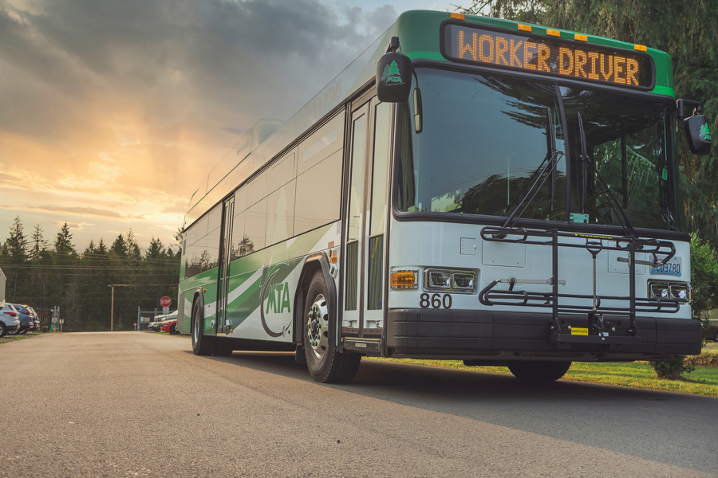

Mason Transit Authority
790 E Johns Prairie Rd
Shelton, WA 98584

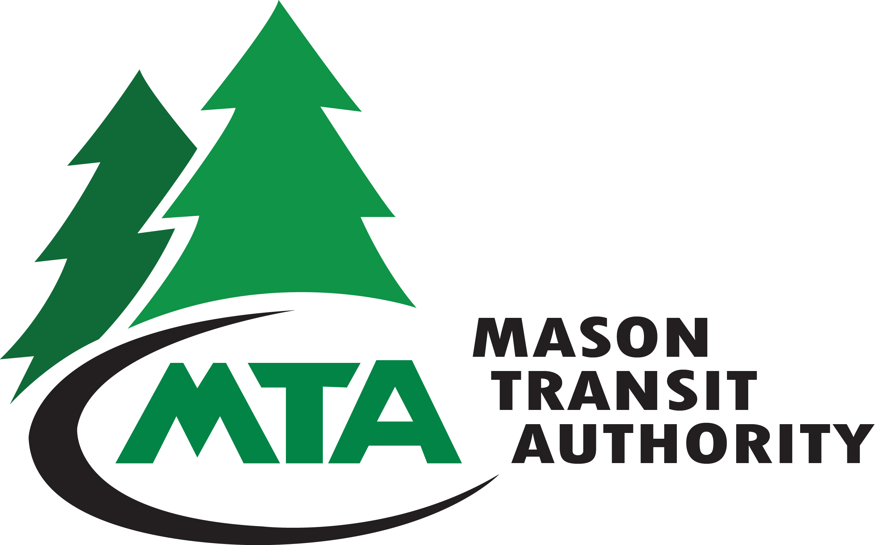
Date of Public Hearing: July 15, 2025
[Adopted: July 15, 2025]
First DRAFT presented 6/17/2025
Second DRAFT presented 7/15/2025

Prepared by Mason Transit Authority Staff

Table of Contents

Plan Adoption, Public Hearing and Distribution 3
Plan Adoption 3
Public Participation Process 3
Plan Distribution 3
Description of Service Area, Operations and Facilities 4
Service Area 4
Operations 4
Map 1 – Service Area 6
Table 1 – 2025 Fares* 7
Facilities 8
Park and Ride Lots 8
State and Agency Goals, Objectives, and Strategies 9
Table 2: 2025 – 2030 Goals, Objectives, and Strategies, and Alignment with State Goals 10
Local Performance Measures and Targets 13
Table 3: 2025 – 2030 Performance Measurements and Targets 13
Plan Consistency 14
Planned Capital Expenses 14
Table 4 – Planned Capital Expenses 15
Planned Operating Changes 16
Table 5 – Planned Operating Changes 16
Multiyear Financial Plan 16
Capital Improvements: 16
Table 6 – Capital Improvement Program (Under Development) 17
Operating Financial Assumptions through 2030 17
Projects of Regional Significance 18
Agency History, Organizational Structure, and Outreach Coordination 18
Board of Directors: 19
Citizen Adviser to the Board: 20
Public Outreach: 20

Plan Adoption, Public Hearing and Distribution

Plan Adoption
Mason Transit Authority (MTA) Board of Directors adopted the 2025 Transit Development Plan on July 15, 2025.

Public Participation Process
Public Comment Period: _________, 2025–July 15, 2025
Comments Submitted to: MTA@masontransit.org
Mason Transit Authority
Amy Asher, General Manager
790 E Johns Prairie Rd
Shelton, WA 98584

Public Hearing: Mason Transit Authority held one public hearing on the Transit Development Plan on July 15, 2025 at 1:00 pm at the Transit-Community Center, 601 W Franklin Ave, Shelton WA 98584. The public hearing was held in conjunction with the Board’s regularly scheduled meeting.

Notice Posted to Website: MTA posted a notice of the hearing on the Transit Development Plan to its website at www.masontransit.org on July ___, 2025.

Notice Published in Local Paper: The Shelton Journal published a notice of the hearing on the Transit Development Plan on July ___, 2025.

Requests for Paper or Digital Copies: MTA allowed the public to request a paper or digital copy of the Transit Development Plan on and after July ___, 2025 by emailing MTA@masontransit.org. or by calling (360) 426-9434.

Available to the Public for Review: MTA allowed the public to view a copy of the draft Transit Development Plan at the Mason Transit Authority Business Office, 790 E Johns Prairie Rd, Shelton, WA 98584 and at the Transit-Community Center, 601 W Franklin Ave, Shelton, WA 98584.

Plan Distribution
On July __, 2025, Mason Transit Authority distributed the adopted Transit Development Plan to:
- PTDPlans@wsdot.wa.gov
- The agency’s assigned WSDOT Community Liaison.
- The Transportation Improvement Board via:
  - Vaughn Nelson, Finance Manager at vaughnn@tib.wa.gov
  - Chris Workman, Engineering Manager at chrisw@tib.wa.gov
- All cities, counties and regional transportation planning organizations within which Mason Transit Authority operates.

Description of Service Area, Operations and Facilities

Service Area
Mason Transit Authority serves the general public throughout Mason County and provides regional connections with other transits and modes of transportation.
Regional connections with other transit systems occur Monday through Saturday with Intercity Transit, and Grays Harbor Transit in Olympia; Kitsap Transit and the Washington State Ferry system in Bremerton; Grays Harbor Transit in McCleary; and Jefferson Transit at Triton Cove State Park. Regional connection with Squaxin Transit occurs Monday through Friday at the Squaxin Island Tribe Park and Ride Facility near the intersection of SR-101 and SR-108.
The majority of MTA’s connecting services are at transfer facilities located near services that allow connections to other ground transportation including Washington State Ferries in Bremerton and Greyhound and Amtrak in Olympia.
Service is available to persons traveling to and from area schools including Olympic College, South Puget Sound Community College, Evergreen State College, and Grays Harbor College by using MTA to transfer to Intercity, Grays Harbor and Kitsap Transit systems at respective transit centers.
Route schedules and maps can be found on MTA’s website at
http://www.masontransit.org/

Operations
MTA has been slowly and sustainably increasing service as new drivers are hired. MTA’s days of operation are Monday – Saturday.
MTA provides services consisting of local and regional deviated fixed routes, Worker/Driver commuter service to Puget Sound Naval Shipyard (PSNS) and Demand Response (general dial-a-ride).
Current hours of operation are 3:25 a.m. to 8:30 p.m., Monday through Friday, and 6:00 a.m. to 7:30 p.m. on Saturday. There is no service on Sunday, and either no service or reduced service on observed holidays, which are listed on MTA’s website. MTA operates twelve (12) Fixed Routes on weekdays and seven (7) routes on Saturdays that allow deviated service to persons traveling off designated routes. Dial-A-Ride service operates in rural areas where there is no fixed route service or where deviations are not possible. It also operates in populated areas of Mason County for people who have difficulty using the routed service. All Dial-A-Ride service is open to the general public. Riders using Dial-A-Ride can make a trip request from two (2) weeks prior to the preferred pick-up time but may request a ride at any time if there is availability. All vehicles in MTA scheduled service are equipped with bike racks and are accessible to persons with disabilities.
MTA coordinates all service requests with other local and regional area transportation providers. Squaxin Transit coordinates local service with MTA regional service at Kamilche. MTA partners with local and regional human and social services providers so that the best service possible is provided throughout the region on a regular basis.

Remainder of Page Intentionally Left Blank

Map 1 – Service Area

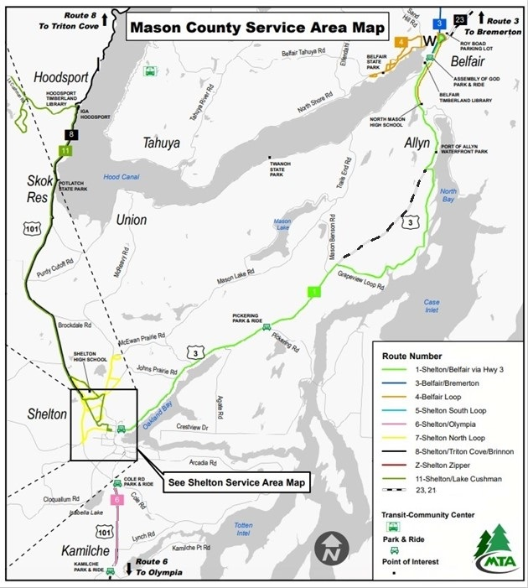

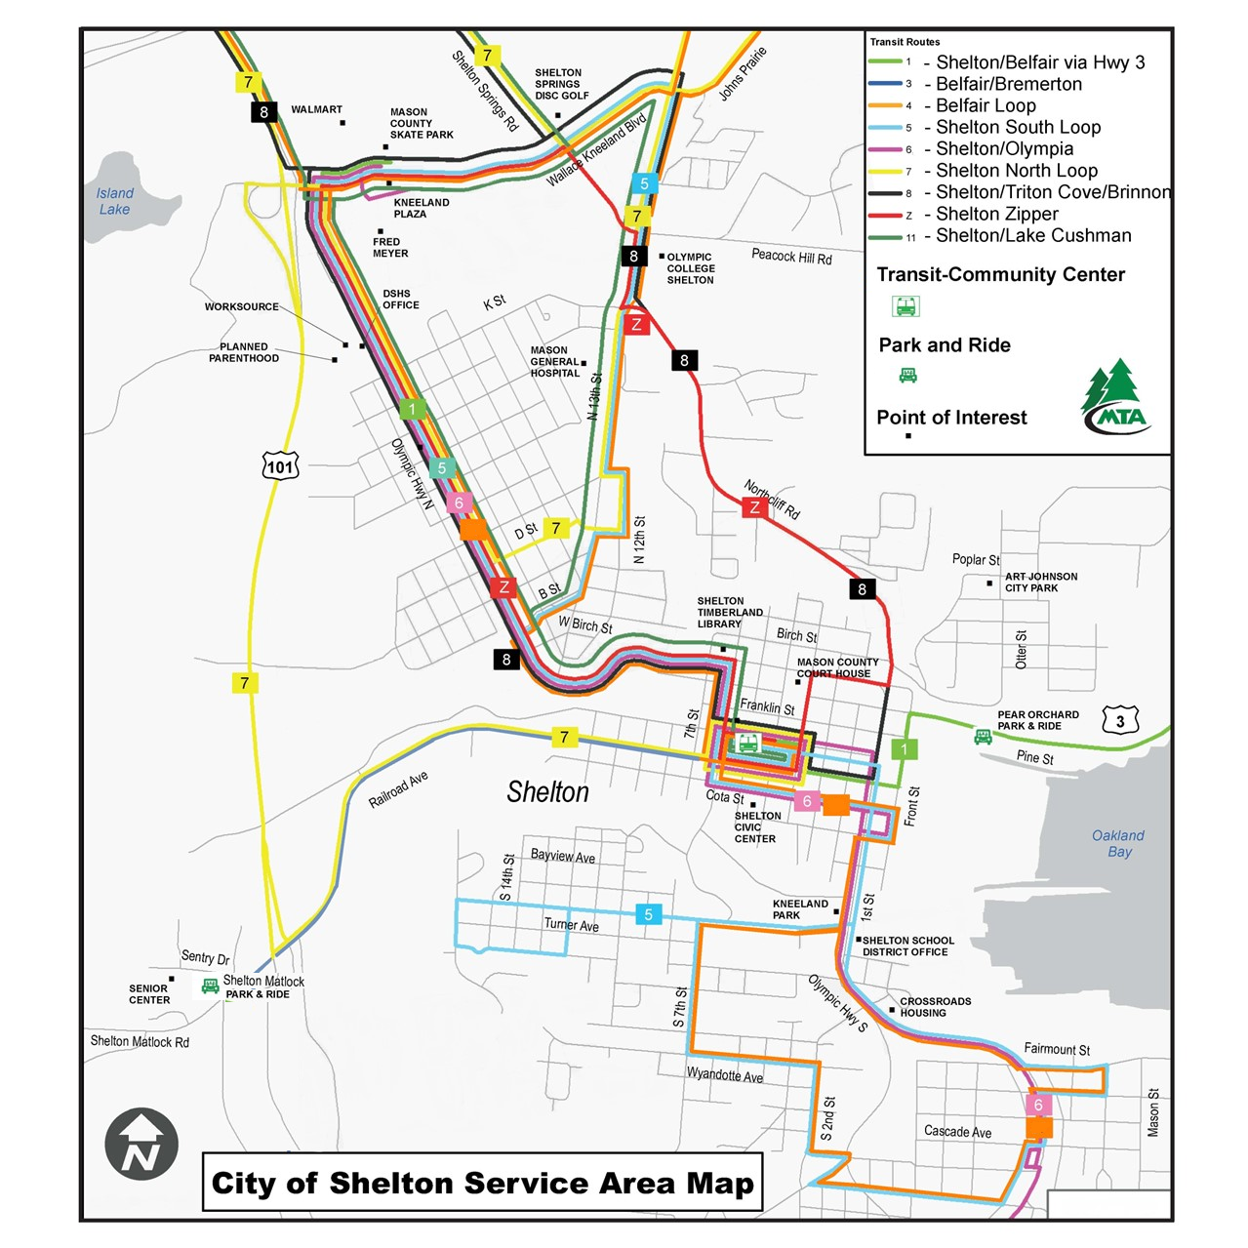

Table 1 – 2025 Fares*
Fare Type | Adult (19+) | Youth (6-18) | Seniors (65+)
Fixed/DAR | Free | Free | Free
Transportation Incentive Program Pass (PSNS) | $110/month | Free | $110/month

*Fares in the table are reported as of the date of publication. By its adoption of Resolution No. 2022-19, the Mason Transit Authority Board (the “Board”) approved a pilot program to suspend fares for all services except the premium Worker/Driver Routes, where only those aged 18 and under ride free, during the period of January 1, 2023 through December 31, 2025. By Resolution No. 2024-16, the Board amended Resolutions Nos. 2022-10 (relating to youth 18 and under) and 2022-19, to extend the end date of the Zero Fare Pilot Program to June 30, 2027.
Those who qualify for a reduced fare due to a disability and plan to use neighboring transit agency systems that do charge a fare are able to apply for a Regional Reduced Fare Permit through MTA. To qualify for reduced fare due to a disability, riders are required to show a Regional Reduced Fare Permit (RRFP) card. RRFP eligibility is based on age, disability or possession of a Medicare card. Personal care attendants ride free when accompanying a person with a RRFP.
Transportation Incentive Program (TIP) passes are available for Worker/Driver routes to and from Puget Sound Naval Shipyard for day shift employees. Routes originate in Belfair and Shelton. Active-duty military personnel with current military ID are not charged fare if ID is shown.

Facilities

MTA operations (including CDL training), maintenance, fleet yard, administrative facilities and employee parking are located at 790 E. Johns Prairie Road in Shelton, Washington. All drivers report to this primary base to begin and end their shift.
MTA owns the Transit-Community Center, formerly the Shelton Armory, located at 601 W. Franklin St. in Shelton, Washington. The facility was renovated with additional new construction transforming the original armory built in the 1950s to a modern, ADA accessible Transit-Community Center (T-CC).
In early 2022, MTA completed the construction of a park and ride and facility in Belfair. The lot contains 100 parking stalls and a building consisting of MTA office space, a meeting room, bathrooms, a kitchen, breakroom and future customer service area. The park and ride is located off the roundabout, also constructed by MTA, at 25250 NE SR 3, in Belfair.

Park and Ride Lots
MTA supports a network of park and ride facilities that are located throughout Mason County. Approximately 330 parking spaces are provided at five facilities owned and operated by Washington State Department of Transportation, Mason County, Mason Transit, and the City of Shelton. While MTA manages and provides routine light maintenance to these locations, the agency does not own the properties, except for Belfair.

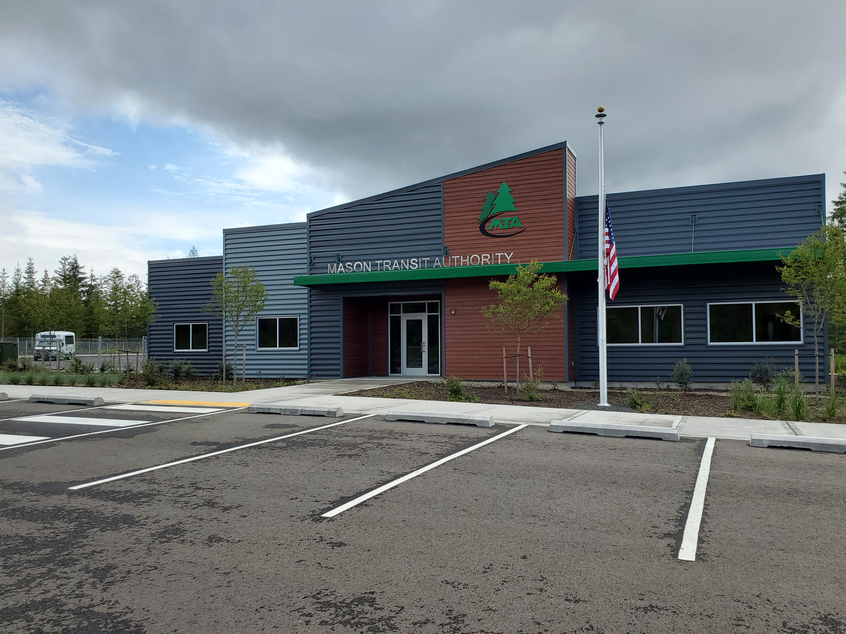
MTA’s Belfair Park and Ride, 2022.

State and Agency Goals, Objectives, and Strategies

From 2025-2030, Mason Transit Authority will focus on the six agency goals in Table 2 below. The table shows how MTA’s local priorities align with state goals established in the Washington State Transportation Plan.
Through its mission, Mason Transit Authority strives to provide transportation choices that connect people, jobs and community; increasing the quality of life in Mason County. To that end, MTA’s proposed project and action strategies line up with the mission statement and the state’s public transportation objectives that are established by the Washington State Legislature through RCW. 47.04.280.

The state’s six policy goals are:
- Economic Vitality: To promote and develop transportation systems that stimulate, support, and enhance the movement of people and goods to ensure a prosperous economy.
- Preservation: To maintain, preserve, and extend the life and utility of prior investments in transportation systems and services.
- Safety: To provide for and improve the safety and security of transportation customers and the transportation system.
- Mobility: To improve the predictable movement of goods and people throughout Washington State, including congestion relief and improved freight mobility.
- Environment: To enhance Washington’s quality of life through transportation investments that promote energy conservation, enhance healthy communities, and protect the environment.
- Stewardship: To continuously improve the quality, effectiveness, and efficiency of the transportation system.

Table 2: 2025 – 2030 Goals, Objectives, and Strategies, and Alignment with State Goals

 | State Goal Areas
Goals, Objectives and Strategies | Economic Vitality | Preservation | Safety | Mobility | Environment | Stewardship
Goal I: Provide a safe and secure transit system for the agency and the public.
Objective 1.1 - Emphasize safety of MTA riders, citizens and employees in all aspects of MTA operations.
L&I inspection of T-CC, JP and Belfair facilities. |  |  | X |  | X
Review WSTIP's Best Practices in the area of safety. |  |  | X
Update Safety Manual and include an emergency safety plan. |  |  | X | X |  | X
Replace vehicles to comply with State of Good Repair goals. |  | X | X |  |  | X
Objective 1.2 - Ensure training for a safe and secure experience for all and to eliminate preventable accidents.
Quarterly Driver training and refresher training as required. |  | X | X
Ensure L&I safety compliance through training. |  |  | X
Objective 1.3 - Proactive approach to safety throughout the agency to increase and improve security throughout the service area.
Change from flag stops to fixed stops in urban area of Shelton. |  |  | X | X |  | X
Objective 1.4 - Enforce transit rules and establish consistency of service to riders in a safe, accessible manner.
Adjust for any mandates as needed. |  |  | X | X |  | X
Goal 2: Effective Transportation Services
Objective 2.1 - Creating a positive transportation experience within all modes of MTA services that is reliable, accessible, equitable, safe, secure and comfortable for all users.
Continue to adjust where needed to improve service as community needs change. |  | X |  |  |  | X
Continue to provide timely, accurate, and clear service updates to the public. |  |  | X | X
Objective 2.2 - Establish a culture of customer service and deliver services that are responsive to community needs.
Benchmark route performance and discontinue or adjust low performing routes. |  |  |  |  |  | X
Objective 2.3 - Strive to look for ways to improve service through a variety of tools including outreach, community meetings, service review and passenger amenities.
Review Dial-a-Ride services and hours to ensure efficiency and availability of resources. |  |  |  | X |  | X
Conduct outreach for all service changes. | X |  |  |  |  | X
Improve passenger amenities by providing apps and on-line scheduling and bus stop amenities. |  |  | X | X |  | X
Objective 2.4 - Seek new opportunities to enhance the riders' experience through better route planning and additional services when feasible.
Seek pilot route opportunities to reach more riders. | X |  |  |  |  | X
Explore on-demand service in Shelton and Belfair. | X | X |  | X |  | X
Goal 3: Financial Stewardship
Objective 3.1 - Operate an efficient, cost-effective system.
Continually review funding opportunities to leverage local resources. |  |  |  |  |  | X
Continue to plan for future capital needs and cost escalations by maintaining a reserve.
Review internal policies and practices continually to ensure resources are used responsibly. | X | X |  |  |  | X
Objective 3.2 - Maintain internal controls and compliance over public resources.
Plan for GASB changes. |  |  |  |  |  | X
Continue to support staff training in their field to maintain compliance with required regulations. |  |  |  |  |  | X
Continued work in public records management. |  |  |  |  |  | X
Goal 4: Community Partnerships and Transportation Choices.
Objective 4.1 - Cultivate partnerships throughout the community.
Participate in outside committees, regional planning organizations and boards. | X |  |  |  |  | X
Continue to work with PR firm to promote MTA services to the community. | X |  |  |  |  | X
Continue to coordinate with local jurisdictions on planning and construction projects. | X | X | X |  |  | X
Participate in community events and partnerships that promote MTA services to the community. | X |  |  | X | X
Participate in mentorship programs at local schools and colleges. | X |  |  |  |  | X
Objective 4.2 - Provide transportation choices and support travel that uses less energy, produces fewer pollutants and reduces greenhouse gases in the region.
Develop a fleet transition plan to determine if alternatively fueled vehicles are appropriate for our service area. | X | X |  |  | X | X
Support efforts to mitigate traffic congestion throughout the region. | X |  | X | X | X | X
Support groups like the PRTPO as well as partnering with other entities to help mitigate traffic. This includes using MTA's park & ride project for transit rider option to single occupant travel. | X |  | X | X | X
Goal 5: Workplace Culture of Excellence
Objective 5.1 - Provide an atmosphere where employees are valued and respected.
Enhance meaningful employee recognition. |  |  |  |  |  | X
Ensure policies are up-to-date and current through a regular review cycle. |  |  |  |  |  | X
Engage employees via quarterly group meetings with management. |  |  |  |  |  | x
Objective 5.2 - Develop and empower employees.
Promote skills and job knowledge through webinars, conferences and training. |  | X | X |  |  | X
Objective 5.3- Be an employer of choice in Mason County.
Continue the Employee Engagement Committee for seeking opportunities to improve the work environment. |  | X |  |  |  | X
Continue to use Paylocity to communicate agency-wide announcements. |  |  |  |  |  | X
Board participation through designated committees. | X |  |  |  |  | X
Continue to provide opportunities for staff participation through designated committees. | X |  |  |  |  | X

Local Performance Measures and Targets

MTA uses various tools to measure performance by looking for key issues and opportunities that may impact the goals of the Agency. Performance indicators may relate to such things as funding, demographic changes, ridership decline or employee shortage. Measuring performance allows the agency leadership team to look for ways to minimize the impact of shortfalls and strategize ways to meet the strategic goals and objectives.
The Transit Asset Management plan is used as a method to maintain and guide decisions on the Agency’s assets, most importantly, rolling stock.

Table 3: 2025 – 2030 Performance Measurements and Targets
Performance Measure | Target
Technology Amenities | Provide apps and icons on the MTA website for customers to schedule
Passenger Amenities | Install lighting in all shelters.  Finalize bus stop improvement plan and install fixed stops in City of Shelton.
Collisions | Collisions per 100,000 revenue miles less than or equal to 1.
Alternative Fuels | Convert 10% of fleet to a green, environmentally friendly alternative by 2025. (Achieved 2025 with entire fleet of diesel vehicles running R99 Fuel, and half of cutaways running on renewable propane).
Transit Productivity | Benchmark of 8 passengers per service hour; 39,000 rides per month. (Achieved in 2024).
Vehicle State of Good Repair | Maintain 80% of the rolling stock within a state of good repair.
Service Hours | To maintain levels of service hours at 1,300 per week at a minimum.

Plan Consistency

Mason Transit Authority is a voting member of the Peninsula Regional Transportation Planning Organization (PRTPO) and participates in the planning of regional projects, policies and program decisions. Information regarding MTA is submitted to the PRTPO’s Coordinated Public Transit-Human Services Transportation Plan to align with the region’s goals. Projects are submitted to the Regional Transportation Improvement Program for inclusion in the State Transportation Improvement Program, when appropriate.
Within Mason County, the Mason County and City of Shelton Comprehensive Plans are used to coordinate consistency. MTA participates in the planning process and submits information to the Plan as required. Staff remain engaged with planning staff and local committees to maintain coordination. Both Mason County and the City of Shelton are in the process of updating their comprehensive plans in 2025.
Throughout the region, MTA coordinates with other connecting transit agencies in Jefferson, Kitsap, Grays Harbor and Thurston counties, as well as efforts to align with the ferry systems, Amtrak and Greyhound.
MTA continues its own strategic planning process by identifying goals, objectives and work plans. Annually, the work plan is reviewed to develop projects adhering to local, state and federal guidelines, implementing effective/efficient service planning changes, fleet replacement standards, facility upgrade and modernization planning and implementation, policy development and modification, and procedural standards.
MTA incorporates the Transportation System Policy Goals throughout all strategies. These goals as addressed in RCW 47.04.280 include preservation, safety, mobility, environment, economic vitality and stewardship.

Planned Capital Expenses

The following table reflects planned capital expenses for 2025-2030. Details of expenses are outlined in the Multi-Year Financial Plan section. For a variety of reasons, MTA has placed on hold its zero-emission fleet transition plan .
An effort to eliminate flag stops within the city limits of Shelton began in 2021 and continues in 2025. Future bus stop improvements will be further refined as we continue planning with the City to determine appropriate stop amenities according to ridership demand and adjacent road and pedestrian networks.

Table 4 – Planned Capital Expenses
Year Received/Expensed | Type | Preservation/Replacement (quantity) | Expansion/Improvement (quantity)
Vehicles
2025 | Light-Duty Alt. Fueled Cutaways | 6
2026 | Light-Duty Alt. Fueled Cutaways | 10
2028 | 35' Alt Fueled Coach (order 2026) | 1
2029 | 35' Alt Fueled Coach (order 2027 after study) |  | 1
2030 | AWD ADA Minivans | 3
Equipment
2025 | Charging Station |  | 1
2026 | Pressure Washer | 1
2026 | IT Equipment | 1
2028 | Security Updates | 1 | 1
Facilities and Infrastructure
2025 | TCC Customer Service Remodel | 1
2025 | Pavement Preservation | 1
2025 | Bus Stop Creation/Improvements | 15 | 15
2025 | Administration Building Upgrade or Replacement Planning/Design | 1
2025 | Pavement Preservation | 2
2025 | Bus Stop Creation/Improvements | 15 | 15
2026 | Bus Stop Improvements | 3
2027 | Propane Station in Belfair |  | 1
2027 | Safety Updates in Belfair Building |  | 1
2027 | Administration Building Upgrade or Replacement Construction | 1 | 1
2027 | Alternative Fueling Station (Type TBD) | 1
2027 | Bus Stop Improvements | 3
2028 | Satellite Maintenance Shop |  | 1
2028 | Bus Stop Creation/Improvements | 3
2029 | Pavement Preservation | 1
2029 | Pavement Preservation | 1
2030 | Bus Stop Improvements | 5

Planned Operating Changes

Table 5 outlines Mason Transit’s planned operating changes for 2025-2030.

Table 5 – Planned Operating Changes
Year | Type | Reduction | Expansion/Improvement
2025 | Explore pilot routes that were put on hold during COVID and implement priorities identified in the most recent Comprehensive Service Analysis. |  | X
2025 | Adjust routes to serve new developments. |  | X
2025 | Continue Mobility Management/Travel Training. |  | X
2026 | Conduct Transit Service Analysis to determine new service needs. |  | X
2026 | Increase Operator FTE's to accommodate operational expansion in 2026/27 |  | X
2026 | Adjust service based on analysis. |  | X
2027 | Continue to add and adjust service as community needs are identified. |  | X
2028 | Continue to add and adjust service as community needs are identified. |  | X
2029 | Continue to add and adjust service as community needs are identified. |  | X
2030 | Continue to add and adjust service as community needs are identified. |  | X

Multiyear Financial Plan

Capital Improvements:
- Future vehicle replacements are expected to be funded at 80% federal or state grants with a 20% match from local sales tax funding. Vehicle costs include the estimated contract price increases as outlined in the State Department of Enterprise Services contract. Cutaway vehicle costs beyond 2026 include a 4% per year annual increase to estimate year of expenditure amounts. The one coach replacement will see a 7% increase over our recent 2024 purchases with the new state contract.
- Feasibility studies are to be conducted for the Fleet Transition Plan, as well as the administration and operations building at John’s Prairie, and satellite maintenance facility station in Belfair.
Facility improvements, preservation and expansion that extend the life of the building according to MTA’s capitalization standards are expected to be funded by grants with local funds used as match. Building repairs or replacement to such equipment will be funded by reserves and appropriated through the capital budget presented annually.

Table 6 – Capital Improvement Program (Under Development)

Operating Financial Assumptions through 2030
- Local Sales Tax – Sales tax revenues in 2024 were up 3% over 2023. Revenues for 2025 to date are up 3% to date. Years 2025 – 2030 are conservatively projected at a 2% growth rate year over year.
- Competitive Operating and Capital Grants, State Formula Funding, and utilization of Sales Tax Equalization dollars (Rural Mobility Formula Funds) for 2025-2030 will be used in conjunction with local sales tax dollars to fund continuing and expanding operations and capital projects. The Climate Commitment Act led to an additional grant program, Transit Support Grants, and to a 50% increase in Paratransit Special Needs formula funding. An initiative to repeal this funding was on the November 2024 ballot and would have greatly reduced MTA’s funding from these programs. Federal funding sources are now unpredictable as a new administration has placed conditions on transportation funding that is in conflict with state laws. Planning for long range transportation operating and capital projects is difficult at best under these circumstances.
- Fare Revenue – Fare revenue forecasts have been adjusted to recent ridership trends in the Worker-Driver Program. MTA is partnering with PSNS on a campaign to encourage the use of the Worker Driver program for shipyard workers. Given the recent fare free pilot project for MTA’s other services, the assumption is a zero fare for 2025-2030.
- Salaries and Benefits – The salary and benefit budget was set to account for capacity for contract negotiations with both Drivers and Maintenance bargaining units. In 2025 MTA continues to strive to expand the number of drivers in 2027 to accommodate a growth in service.

Table 7 – Operating Financial Plan (Under development)

Projects of Regional Significance

Mason Transit Authority completed its project of regional significance in 2022 with the construction of a series of park and rides throughout Mason County. The next significant work for MTA will begin with movement toward low and no emission vehicles in its fleet as it continues to convert to use of renewable propane and diesel. MTA will be developing a Fleet Transition Plan that will evaluate the current available zero emission and clean fuel technology, estimate MTA’s carbon reduction over time, create a resiliency plan, identify infrastructure requirements, utility and fueling needs, coordination with other entities, funding strategies and partnerships, and workforce training needs to determine if incorporating zero emission vehicles into the fleet is a long term viable option. MTA is also planning on the re-development of the MTA John’s Prairie Base. Re-development will include accommodations for expanded alternatively fueled fleet, administrative building that is ADA compliant and allows for room to accommodate MTAs future growth.

Agency History, Organizational Structure, and Outreach Coordination

Mason County Public Transportation Benefit Area, doing business as Mason Transit Authority (MTA), is a Public Transportation Benefit Area (PTBA), authorized in Chapter 36.57A RCW. Located in Mason County, Washington, the Mason County voters approved the PTBA in November 1991 and began public transportation service in December 1992. The service area includes all of Mason County, if road access is available, with connections to adjacent counties.
The proposition imposing a sales and use tax of two-tenths of one percent (0.2%) to fund public transportation was also passed in 1991, creating a prepaid fare system service. In the aftermath of Initiative 695 and the elimination of Motor Vehicle Excise Tax that was available to transits, the voters were asked to approve an additional four-tenths of one percent increase (0.4%) in 1999. The first attempt failed but was successful when County residents responded with an approval of the additional sales tax increase on September 18, 2001. This raised the taxing base to six-tenths of one percent (0.6%) or $.06 on every $10 of retail sales, effective January 1, 2002. MTA then began to charge a fare, but only for routes going out-of-county.

Board of Directors:
The Mason County Public Transportation Benefit Authority Board of Directors is composed of ten members as follows:
- Three (3) elected members representing Mason County Commissioners;
- One (1) elected member representing the City of Shelton Council;
- Five (5) members who shall be elected officials selected by the Mason County Commissioners with the goal of seeking equal voting representation among the County Commissioner Districts. The recommendation was approved by Mason County and the City of Shelton pursuant to Resolutions Nos. 71-17 and 1112-1217, respectively; and on October 25, 2021, approved by motion to keep the Board structure the same and to make no changes to the composition of the Mason Transit Authority Board.
- In accordance with revisions made to RCW 36.57A.050, there shall be one (1) non-voting labor representative recommended by the labor organization representing the public transportation employees.
Mason County Public Transportation Benefit Authority (MTA) Board Members at time of publication are:
- John Sheridan, Port of Allyn (Chair)
- Wes Martin, Grapeview School District (Vice Chair)
- Randy Neatherlin, Mason County Commissioner
- Pat Tarzwell, Mason County Commissioner
- Sharon Trask, Mason County Commissioner
- Ryan Spurling, Mason County Sheriff
- Tom Gilmore, City of Shelton Council
- Cyndy Brehmeyer, Mary M. Knight School District
- Richard Lee, Pioneer School District No. 402
- Zachary Collins, Bargaining Unit Representative (non-voting)

Citizen Adviser to the Board:
Effective January 1, 2019, there may be one (1) non-voting representative of the public residing in Mason County, Washington, as a citizen adviser to the Board. The citizen adviser to the Board shall serve for a period of one year (unless extended by motion by the Authority Board).
At the time of publication of the Transit Development Plan, the position of the Citizen Adviser to the Board was filled by:
- John Piety

Public Outreach:
MTA staff is committed to public engagement and transparency through robust public interaction that informs, involves, and empowers people and communities. Staff participate in several opportunities to promote and educate citizens through the following methods:
    - Public meetings
    - Media – outreach
    - Radio spots
    - Community events and meetings
    - Presentations
    - Website improvements
    - Social Media
The public outreach program includes:
- Developing an awareness of MTA services with non-riders through presentations, media and community events.
- Engaging riders and the general public by soliciting feedback through active seeking of information by face-to-face interaction and surveys.
- Seeking opportunities to increase ridership amongst riders of choice.
- Visiting businesses to discover ways to assist their employees with transportation, either by using fixed-route or Dial-a-Ride.
- Promoting positive public image in the community and build relationships throughout.
- Public Hearings for service changes, Transit Development Plan (TDP), fare changes, and other topics that impact citizens.
There are comment cards on MTA vehicles to be filled out and submitted as a method to communicate compliments, complaints or other information a rider wants staff to be aware. Management or designated staff responds to the individual comment cards as appropriate.

Citizens may contact MTA through customer service or to an individual by the following methods:
Email: mta@masontransit.org
Phone: 360-427-5033 or 360-426-9434 or 800-374-3747
TTY/TTD: 711 or 800-833-6388
Website: www.masontransit.org
Individual staff members may be contacted through using the website or phone to locate email addresses or phone extensions.

For ADA needs, citizens may use the website or call customer service for assistance.

