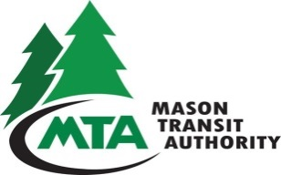
BOARD COMPOSITION REVIEW
OF MASON TRANSIT AUTHORITY BOARD

AGENDA FOR CONTINUED MEETING

Remote Meeting via Zoom:
https://zoom.us/j/95950949379?pwd=2NEJ9VpT2Agslf0S8asqmW4c5fgawp.1
To join by phone: 12532050468

Meeting ID: 959 5094 9379
Passcode: 517907

In person attendance:
Belfair Park & Ride Building
Conference Room
25250 NE SR3
Belfair

Date: October 21, 2025
Time: Immediately following the Regular MTA Board Meeting
Place: Belfair Park & Ride Building Conference Room
25250 NE SR3
Belfair

Designated Representatives: Commissioner Sharon Trask (Mason County), Commissioner Randy Neatherlin (Mason County), Commissioner Pat Tarzwell (Mason County) and Councilmember Tom Gilmore (City of Shelton)

- Introduction and Procedural Instruction – (MTA Legal Counsel)
- Selection of Chairperson
- Designation of Clerk/Recording Secretary
- Discussion: Board Composition Review
After a public transportation benefit area has been in existence for four years, members of the county legislative authority and the elected representative of each city within the boundaries of the public transportation benefit area shall review the composition of the governing body of the benefit area and change the composition of the governing body if the change is deemed appropriate. The review shall be at a meeting of the designated representatives of the component county and cities, and the majority of those present shall constitute a quorum at such meeting. Twenty days’ notice of the meeting shall be given by the chief administrative officer of the public transportation benefit area authority. After the initial review, a review shall be held every four years.
- Bylaws Revision Review (required if changes to Board Composition are deemed appropriate).
- Adjourn

